CURRICULUM VITAE

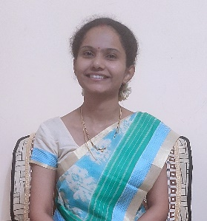

Name: Dr. Janki Gurpude Mhaske
Age: 29yr. / Female
Date of Birth: 02/01/1995
Address: Janeev Rugnalay Geora Buj, Saoli Dist. Chandrapur 441215
Mobile No.: 8788010417/8007152494
Email: gurpude.janki@gmail.com
BDS reg.no. A- 37363

Education:
Qualification | Institution | University/ Board | Year Pass out | Percentage
SSC | Janata Mahavidyalaya, Nagbhid, Dist.Chandrapur | Rashtrsant Tukdoji Maharaj Nagpur University, Nagpur, Maharashtra. | 2010 Summer | 84.18%
HSC | Janata Junior College, Nagbhid, Dist. Chandrapur | Rashtrsant Tukdoji Maharaj Nagpur University, Maharashtra. | 2012 Summer | 72.17%
BDS | Swargiya Dadasaheb Kalmegh Smruti Dental College and Hospital Nagpur | Maharashtra University of Health Science, Nashik, Maharashtra. | 2016 Summer | 61.50%

Work Experience and Internship:
Work Year | Institute | Designation | Responsibilities
1 Oct 2017 - 23 March 2021  (3 years 5 months) | Pitruchaya Dental Clinic,  Dr. Chandrakant Lachure, Sakkardara Square, Nagpur | Assistant Doctor | 1. Daily OPD.  2. Managing the treatment of dental patients.  3. Diagnosing the oral disease and creating treatment plan  4. Performing root canal treatment and other conservative and restorative procedure.  5. Performing root canal treatment and oral prophylaxis treatment in pediatric patients.  6. Taking radiograph and their interpretation.  7. Performing routine dental extraction.  8. Insuring safe administration of local anesthesia.  9. Performing scaling and polishing and root planning procedure.  10. Educating and motivating the patients to maintain oral hygiene.  11. Proscribing antibiotics and analgesic to patients.  12. Counselling the patients to stops tobacco, alcohol
1 Jan 2022 onwards  (3 Years 6 months) | Sobat Foundation Chandrapur  Janeev Rugnalaya, Geora Buj. Taluka: Saoli, District: Chandrapur | Co-Director / Incharge Dentist | 1.Direct the regular administrative activities of Hospital  2. Provide dental care and conduct dental procedures in regular Dental Clinic  3. Provide Mobile Dental Care Service in around 40 Villages through camps  4. Conduct Adolescent Education activities in school and coordinate Sports and Cultural activities for Villagers.

